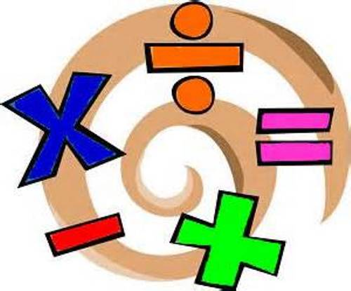
Maths Information Workshops:
Approaches to Calculation
Wednesday 28th February 2018 for parents and carers of children from Year 1 to Year 6
Your continued role in helping your child with their mathematical knowledge and understanding in calculation is very important and we value the support that you give. Learning to add, subtract, multiply and divide can be complex and children learn in different ways. At the maths information workshops we will explain the different approaches used appropriate to the different levels of ability and age groups. The workshops are an ideal opportunity for you to ask questions and talk to staff. Some of the resources that we use will also be available for you to look at and try.
We hope you will be able to attend one of these meetings and find out how you can help your child at home. The table below shows the breakdown of key stages and timings. It is suggested that parents with siblings in two different groups attends the older child’s workshop as there will be a review of methods used from the previous years.
4-5pm | 5-6pm
Key Stage 1 | Key Stage 2

Thank you,
Miss Holbrook.
------------------------------------------------------------------------------------------ Maths Information Workshop 2018
Name of child: _________________________________ Class ________________________ I/we will be attending the Maths Information Workshop on Wednesday 28th February 2018.
Please indicate the workshops you will be attending (please circle):
KS1 4-5pm KS2 5-6pm
Parent signature:
Date:
PLEASE RETURN TO THE SCHOOL OFFICE BY FRIDAY 23RD FEBRUARY 2018

